**Assignment -1**

SMART HOME AUTOMATION

|  |  |
| --- | --- |
| Assignment Date | 19 September 2022 |
| Student Name | Keerthika M |
| Student Roll Number | 113119UG07046 |
| Team Id | PNT2022TMID22571 |

Question: Build smart home automation with sensors and LED using tinkercad

CIRCUIT DESIGN

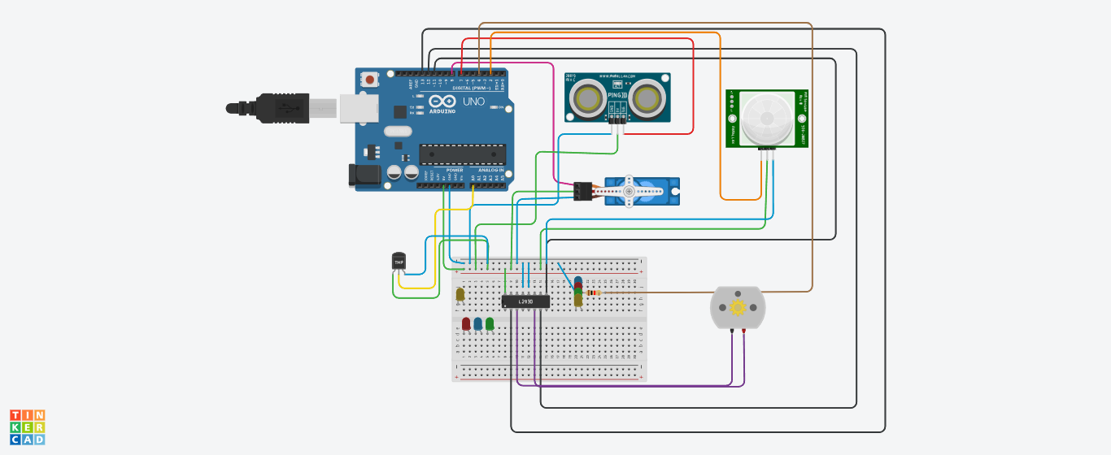

“Home automation” refers to the automatic and electronic control of household features, activity, and appliances. In simple terms, it means you can easily control the utilities and features of your home via the Internet to make life more convenient and secure, and even spend less on household bills.

Home automation is a network of hardware, communication, and electronic interfaces that work to integrate everyday devices with one another via the Internet. Each device has sensors and is connected through WiFi, so you can manage them from your smartphone or tablet whether you’re at home, or miles away. This allows you to turn on the lights, lock the front door, or even turn down the heat, no matter where you are.

The above circuit is done using the arduino board, DC motor, PIR sensor, LED, temperature sensor, relay.

If the temperature increased to a certain level the fan will be on (dc motor), if the brightness of the room is low, the LED will be on

**Program:**

#include<Servo.h>

const int pingPin = 7;

int servoPin = 8;

Servo servo1;

void setup() {

// initialize serial communication:

Serial.begin(9600);

servo1.attach(servoPin);

pinMode(2,INPUT);

pinMode(4,OUTPUT);

pinMode(11,OUTPUT);

pinMode(12,OUTPUT);

pinMode(13,OUTPUT);

pinMode(A0,INPUT);

digitalWrite(2,LOW);

digitalWrite(11,HIGH);

}

void loop() {

long duration, inches, cm;

pinMode(pingPin, OUTPUT);

digitalWrite(pingPin, LOW);

delayMicroseconds(2);

digitalWrite(pingPin, HIGH);

delayMicroseconds(5);

digitalWrite(pingPin, LOW);

// The same pin is used to read the signal from the PING))): a HIGH pulse

// whose duration is the time (in microseconds) from the sending of the ping

// to the reception of its echo off of an object.

pinMode(pingPin, INPUT);

duration = pulseIn(pingPin, HIGH);

// convert the time into a distance

inches = microsecondsToInches(duration);

cm = microsecondsToCentimeters(duration);

//Serial.print(inches);

//Serial.print("in, ");

//Serial.print(cm);

//Serial.print("cm");

//Serial.println();

//delay(100);

servo1.write(0);

if(cm < 40)

{

servo1.write(90);

delay(2000);

}

else

{

servo1.write(0);

}

// PIR with LED starts

int pir = digitalRead(2);

if(pir == HIGH)

{

digitalWrite(4,HIGH);

delay(1000);

}

else if(pir == LOW)

{

digitalWrite(4,LOW);

}

//temp with fan

float value=analogRead(A0);

float temperature=value*0.48;

Serial.println("temperature");

Serial.println(temperature);

if(temperature > 20)

{

digitalWrite(12,HIGH);

digitalWrite(13,LOW);

}

else

{

digitalWrite(12,LOW);

digitalWrite(13,LOW);

}

}

long microsecondsToInches(long microseconds) {

return microseconds / 74 / 2;

}

long microsecondsToCentimeters(long microseconds) {

return microseconds / 29 / 2;

}

TINKERCAD LINK

<https://www.tinkercad.com/things/dfd3Quaj8V9-surprising-trug/editel>